☑️ Abstract
Shake Table Test, a test to simulate the gauging the structural integrity during seismic activity, inadvertently causes the vibration of nearby buildings. The comfort level quantification process of these vibrations before conducting a shake table test can be efficiently estimated using a 1D CNN.
A three-dimensional numerical model of the shake table–soil–surrounding building system is established and validated through the finite element method.
A dataset of peak acceleration values and time-history of the triaxial ground motion (inputs) and three-directional acceleration response for nine measuring points of surrounding buildings (output) is simulated followed by training and testing the model to directly extract dynamic features from triaxial ground motion accelerations and to accurately estimate the weighted acceleration level (WAL) of nine different locations at the surrounding buildings.
Final verification is done by using an actual shake table experimental test on a self-centering concrete structure.

☑️ Aim of the Paper
Creating a DL-based method that can create simple and accurate surrogate models to substitute complex and computationally expensive dynamic systems (FEM). By extracting useful features from massive training data, the DL network will be able to efficiently analyze the vibrations for structure assessment and comfort prediction.

In this paper, a DL-aided framework is proposed to quantify and estimate the vibration comfort of the STL and surrounding buildings during operation of the shake table.

☑️ Current Scenario and Problems
Shake Table Test:-
Shake table test is developed to simulate earthquake-induced ground motions and to reproduce nonlinear dynamic response of structures during earthquakes,which has been the most efficient and realistic approach for structural seismic performance evaluation.
- Evaluating Seismic Performance
- Testing Full-Scale Models
- Reproducing Realistic Conditions: Unlike computer simulations alone, shake tables provide physical data on how materials and joints fail under stress

How does a shake table test work?
- Pre-Experiment Estimation & Design: Design "loading scenarios"—specific seismic waves (like the Wenchuan or El Centro earthquakes) to be simulated based on the test objectives.
- Loading and Setup: The test structure is securely mounted onto the table surface.
- Excitation: Applies triaxial ground motions (vibrations in three directions) to the structure.
- Monitoring and Data Collection: Sensors (accelerometers) on the structure and in the surrounding area record real-time data, such as three-directional acceleration responses.
- Post-Test Analysis: Analyze the collected data to determine structural damage, displacement, and performance against seismic standards.

Problems of Shake Table Test:-
- Foundation and Soil Vibrations of the building with the shake table itself.
- Building Disturbances: Go directly into the foundations of nearby buildings, causing "feelable vibration" on every floor.
- Secondary Noise
- Interference with Sensitive Equipment: In university or research settings, floor vibrations can negatively impact the precision of electronic devices and medical instruments in neighboring laboratories.
- Human Discomfort: High Weighted Acceleration Levels (WAL) can lead to a lack of "vibration comfort," making it difficult for people in nearby buildings to work or live comfortably during tests
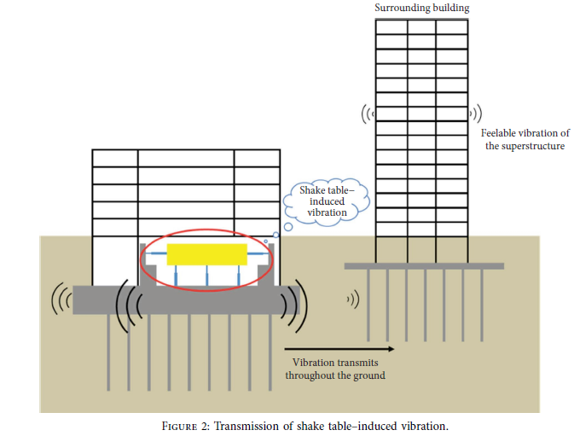

Current Scenario and Problems Faced by the Facility under Study:-
- As an excitation source, the large shake table not only triggers vibration of the tested structures on the table but also causes significant dynamic loads on its foundation and surrounding soil, leading to vibration of the whole laboratory building. ]
- The vibration is transmitted directly through the foundations of the nearby buildings, and ultimately results in feelable vibration and secondary noise on every floor of the superstructures, as shown in Figure 2.
- The floor vibrations also influence precision of the research-oriented electronic devices and medical instruments housed in the surrounding buildings as well as causing discomfort to people in the buildings.
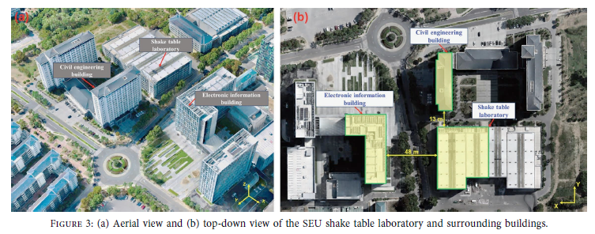
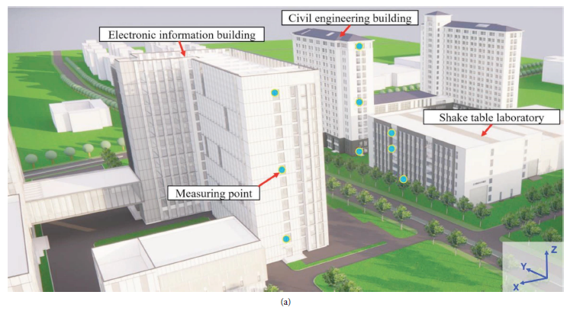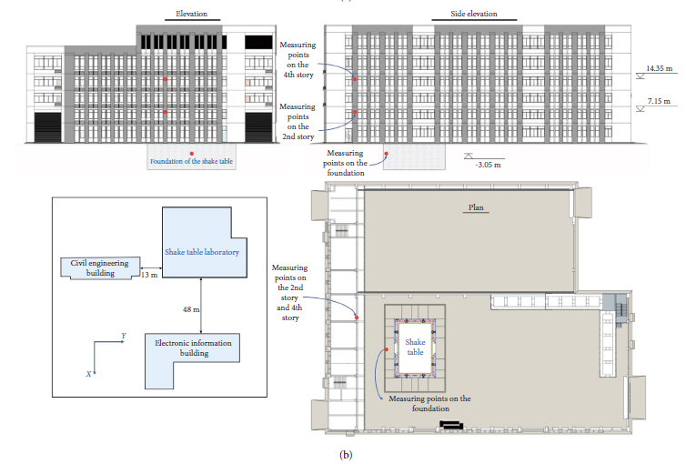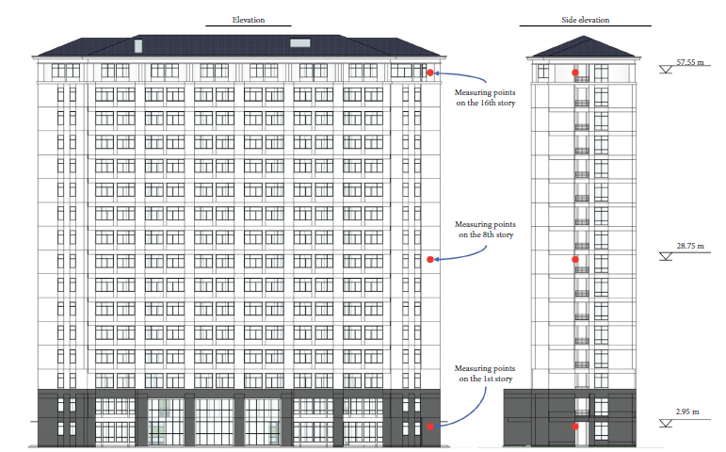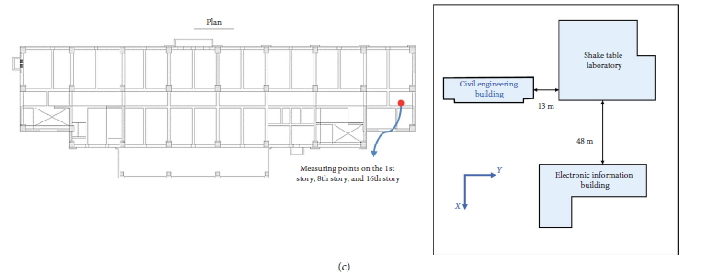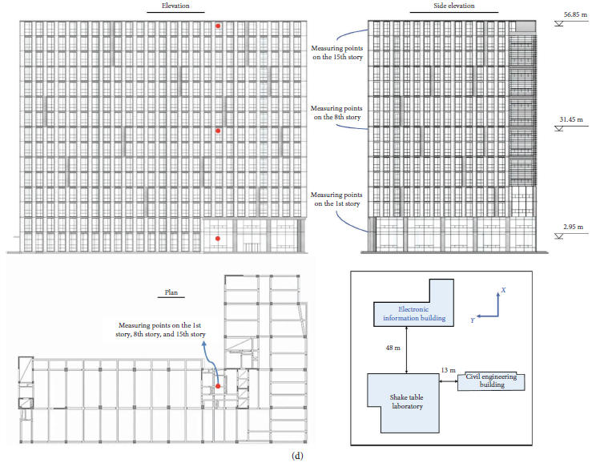

FEM:-
FEM (Finite Element Method) is a numerical technique used to solve complex engineering and mathematical problems.
Instead of trying to solve a massive, complicated structure all at once, FEM breaks it down into thousands (or millions) of smaller, simpler shapes called "elements" (like tiny triangles or cubes). These elements are connected at specific points called nodes. By calculating how each individual element reacts to a force, the computer can stitch them all together to predict how the entire large-scale structure will behave.

FEM is used to:-
- Virtual Prototyping: It allows researchers to "test" how a building will react to an earthquake without actually having to build a physical model or wait for a real disaster.
- Data Generation: FEM is used to create "ground truth" data.

While FEM is excellent for accuracy, the paper explains why it is not preferred for real-time or pre-experiment planning:
- Extreme Computational Cost
- Time Consuming
- Complexity

✅ Proposed Framework
Overview of the Process of Making a DL Based Framework for Pre-Shake Table Experiment Vibration Comfort Estimation:-
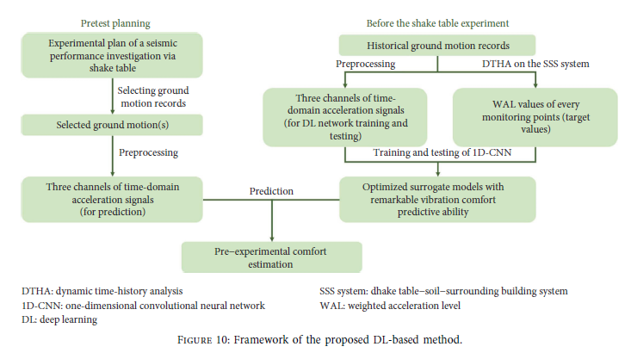
- Prepare a dataset of historical ground motion records that can be employed on a shake table test.
- Carry out DTHA (Dynamic Time History Analysis) on the SSS (Shake Table Soil Surrounding) system with each ground motion signal to obtain the vibrational responses at different monitoring points of the three surrounding buildings and to compute their WAL values.
- Develop the mapping principles between computed WAL values and ground motions using a DL network.
The preprocessed triaxial acceleration signals of each ground motion, along with the corresponding WAL values, serve as input–output pairs for training a one-dimensional convolutional neural network (1D-CNN) model.
- When planning a seismic performance investigation through shake table experiment, the selected records for simulating real ground motions are obtained and input into the optimized 1D-CNN model to estimate their corresponding vibration comfort.

Step 1:- Preparation of Dataset:-
- To collect sufficient ground motion records for training the DL network, several open-access ground motion databases can be utilized.
- To adapt ground motion records of various formats, signal preprocessing is done for each selected record.
  - First, the acceleration signals in three directions of each ground motion record (ax and ay and az), are normalized and multiplied by a scaling factor
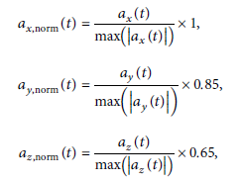
  - The acceleration signals of each ground motion record is resampled because the selected ground motions are recorded by different seismographs and their sampling frequencies varied. The polyphase resampling method is employed to adjust the sampling frequency of each signal to 50 Hz. (avoids frequency aliasing and mirroring during sampling rate conversion in signal processing)
  - The duration of each ground motion is standardized before input into the DL network (minimum=20 s and between 5 and 10 times the fundamental period of the structure being tested.
- In order to assess the impact of different ground motions operated by the shake table on the vibration comfort of the surrounding buildings, DTHA is conducted on the numerical model of the SSS system
The triaxial acceleration responses of the nine measuring points on the surrounding buildings excited by the selected ground motions are obtained, and the WAL values of vibrations at every point are computed by
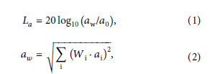
For different operating conditions of the shake table test, the bearing weight and peak acceleration of the simulated earthquake always vary, even though the same ground motion records are chosen. So the influence of bearing weight and different adjustment coefficients of the shake table test is also considered during the dynamic analysis.
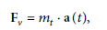
where Fv is the reaction force of the actuators in the SSS system and mt is the total mass of the shake table system and its bearing weight. a(t) is the acceleration vector of the triaxial ground motion. The at can be replaced by aeq(t) which is 3D vector of acceleration.
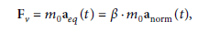
Step 2:- DL Network Training and Testing:-
- The network is trained and tested using preprocessed ground motion records and computed WALs. To synchronously extract and analyze the intrinsic features of the three-directional acceleration signals, the 1D-CNN model is structured with multichannel one-dimensional convolutional kernel layers and fully connected deep neural network layers.
- Testing of the optimized DL network is conducted through two phases.
First, the model will analyze the three directional acceleration signals from the testing dataset and output the predicted WAL values for nine measuring points, and the nonlinear feature extraction/regression performance of the model will be examined.
Second, an actual shake table experimental test will be performed, and the estimated vibration comfort level of different measuring points will be compared with the on-site monitoring data.
To estimate the potential adverse effects of the shake table test, a preprocessing program is employed to process the prepared ground motion data and to generate three channels of scaled accelerations. These signals are then input into the optimized 1D-CNN model, which can anticipate the vibration comfort at nine different locations in the three surrounding buildings by means of the WAL values.
By comparing the output WALs with the predetermined thresholds at corresponding points, the vibration comfort state of these locations can be estimated.

Statistical Analysis:
The mean absolute percentage error (MAPE) is utilized to measure the error between the
predicted values and the actual values
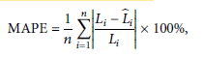
where n is the total number of data, Li is the ith actual value of output data, and 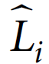 is the ith predicted value of output data.

Benefits and Future Prospects
The designed 1D-CNN model that inputs the normalized three-directional ground motion signals and PGAs can well predict the vibration effect of the shake table on the surrounding buildings by estimating the WALs for nine triaxial accelerometers.
The MAPE values are within 0.417% for the training dataset and 0.348% for the testing dataset; the R2 values at each measuring point exceed 0.98 for both training and testing datasets.

Analysis and Coding Part
Dataset used for Simulation Process in the Paper:-
A dataset, comprising 9772 groups of triaxial ground motion signals as inputs and vibration comfort levels as outputs, is prepared through dynamic time-history analysis
(DTHA) of the shake table–soil–surrounding building (SSS) system.
The model optimized with the dataset is used to analyze 2443 groups of new input records with different peak ground accelerations (PGAs)and the vibration comfort estimation performance of the model is tested and discussed.

Some Important definitions
DTHA:- Dynamic Time-History Analysis
SSS:- Shake Table-Soil Surrounding
Structural Health Monitoring System (SHMS). To investigate the impact of shake table–induced vibration on the surrounding structures, a SHMS is established by installing accelerators at different locations of the laboratory and the two surrounding buildings; thus, the vibration comfort of every measuring point can be calculated when
shake table tests are conducted.
At each measuring point, three unidirectional magnetoelectric accelerometers are installed to capture the real-time vibration response in the vertical direction as well as in the two horizontal directions.
The SHMS can automatically evaluates the vibration comfort level during operation of the shake table. Considering the four factors for vibration signal evaluation, namely, the intensity, direction, frequency, and exposure duration of the vibration, the weighted acceleration level (WAL) is employed as the index for quantifying vibration
comfort evaluation based on the ISO 2631-2 2 standard:
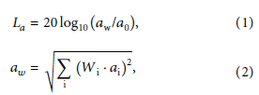
where aw represents the weighted root-mean-square (RMS) value of the input acceleration data, serving as the primary index for comfort evaluation. Wi and ai denote the ith weighting factor and RMS acceleration value for the corresponding one-third octave band. a0 is the reference acceleration
and its value is 10−6 m/s2.
According to the Chinese GB 50868 standard, thresholds for the WAL values at different measuring points are specified with reference to the usage functions of the three
Buildings,
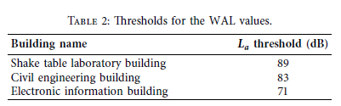
Before the STL was put into service for seismic ground motion experiments of real-sized structures, a series of tests were conducted to investigate the influence of shake
table–induced vibration on the surrounding buildings. These tests included frequency sweep wave test, sine wave test, and seismic time-history wave test.
